EXPERIMENT 3

AIM: Working with Docker Volume

1. View all Volume in Docker

Command: - docker volume ls

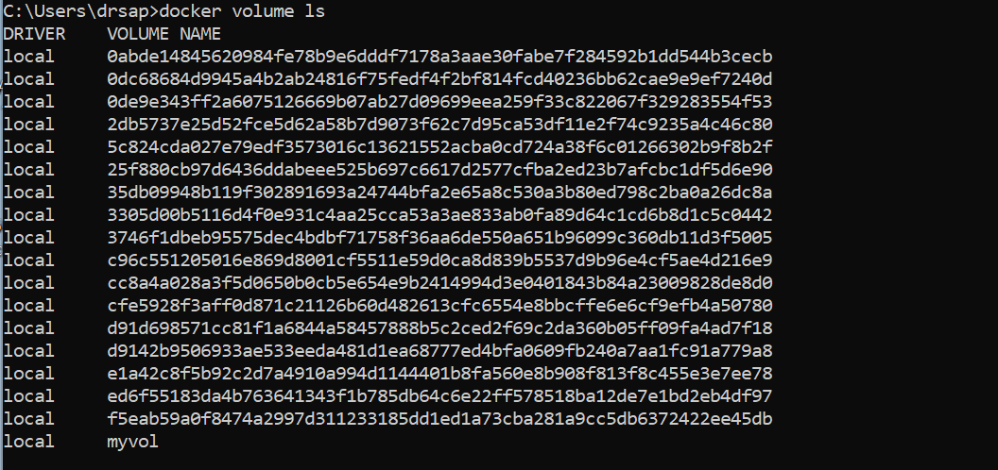

1. Create a new Volume

Command: -docker volume create myvol1

Command: -Docker volume ls

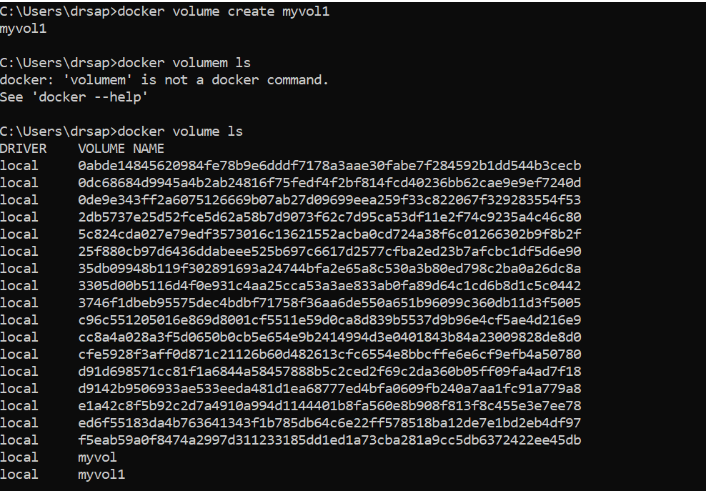

1. Mount a Volume with a container

Command: -docker run -it -v myvol1:/data redis /bin/bash

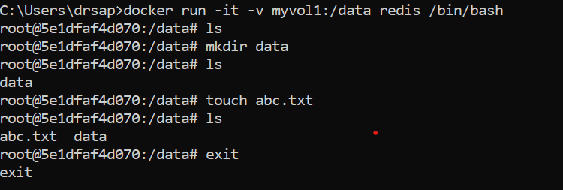

1. Create another container and Mount with the same Volume

Command: -docker run -it -v myvol1:/data redis /bin/bash

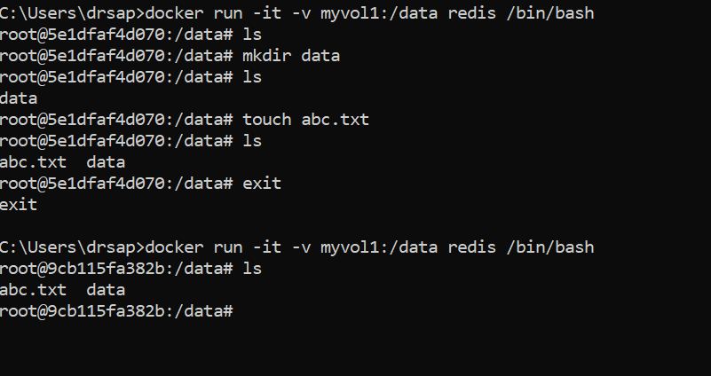

1. See the complete working of container



1. Exited from container and restart again to see the persistent of Docker Volume

Command: - docker start 5e1df

Command: - docker attach 5e1df

